INSTRUCTION

What is the object-oriented example?  
For example, say we created a class, Car, to contain all the properties a car must have, color, brand, and model. We then create an instance/behavior/method of a Car type object, myCar to represent my specific car.  
Could you please create another 5 object-oriented examples and give all their properties and their instances/behavior/method?

SUBMISSION

1. Use graphics to show the examples.
2. Use Word Documents and attached the file to your GitHub
3. Submit your link GitHub for this exercise into my GitHub before 25 Mac (Thursday) at 12.00 pm.
4. **Class: Fruits**

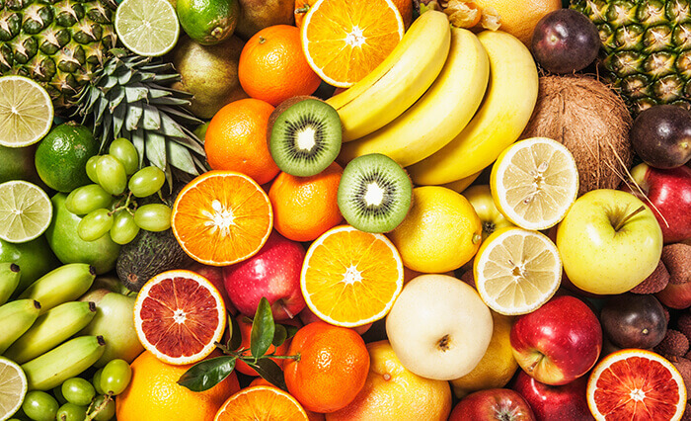

Properties: colour, fragrance, main components, appearance

Instances: apple, banana, orange, pineapple

Behaviours: provides health benefits, provides vitamins, prevent constipation, reduce risk of getting sick

1. **Vegetables**

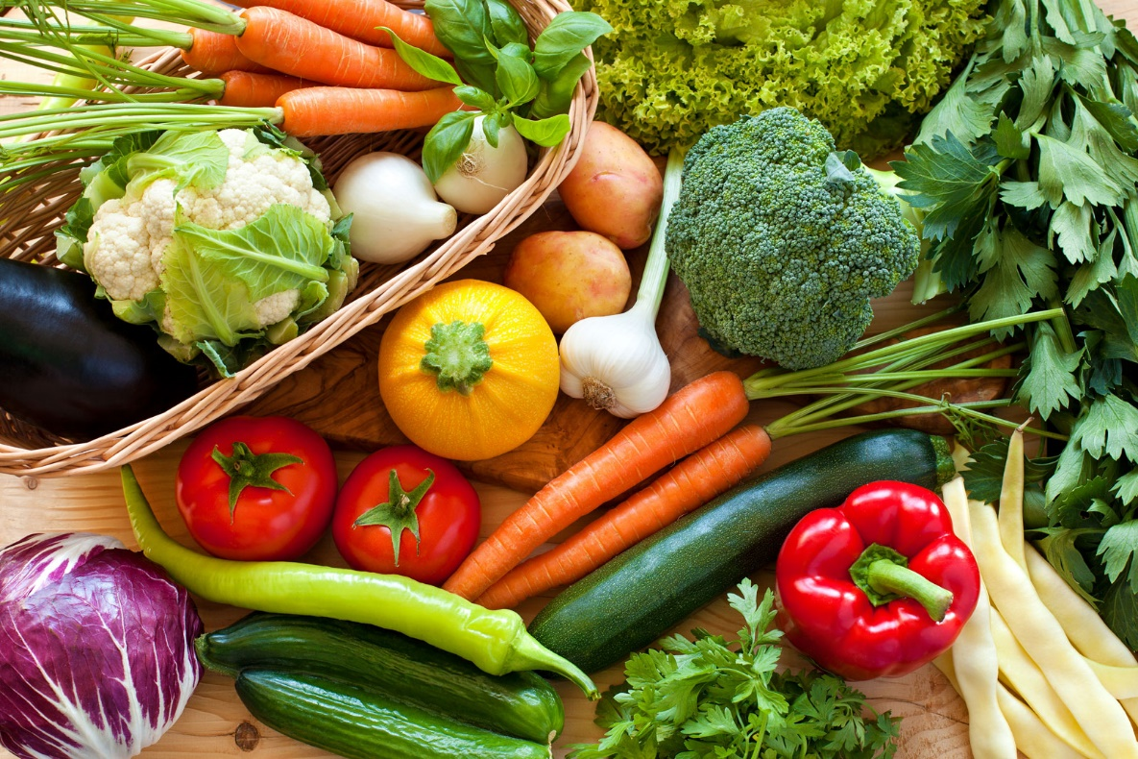

Properties: colour, main components, appearance

Instances: tomato, carrot, onion, bell pepper

Behaviours: reduce risk of heart disease, provides essential minerals, prevent constipation, provides health benefits

1. **Meat**

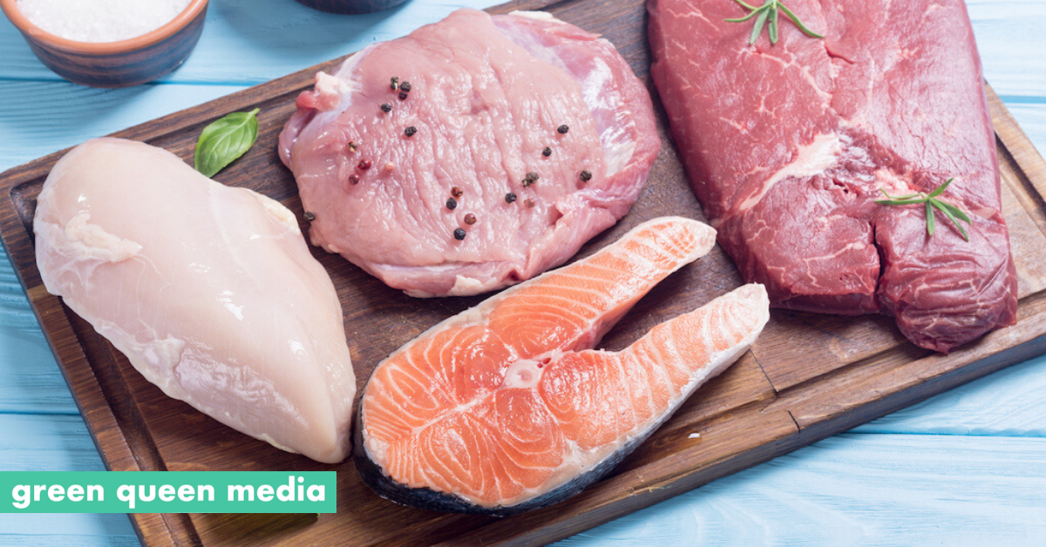

Properties: flavour, tenderness, juiciness

Instances: red meat, poultry, pork, seafood

Behaviours: provides protein, made into different food items, can be cooked

1. **Drinks**

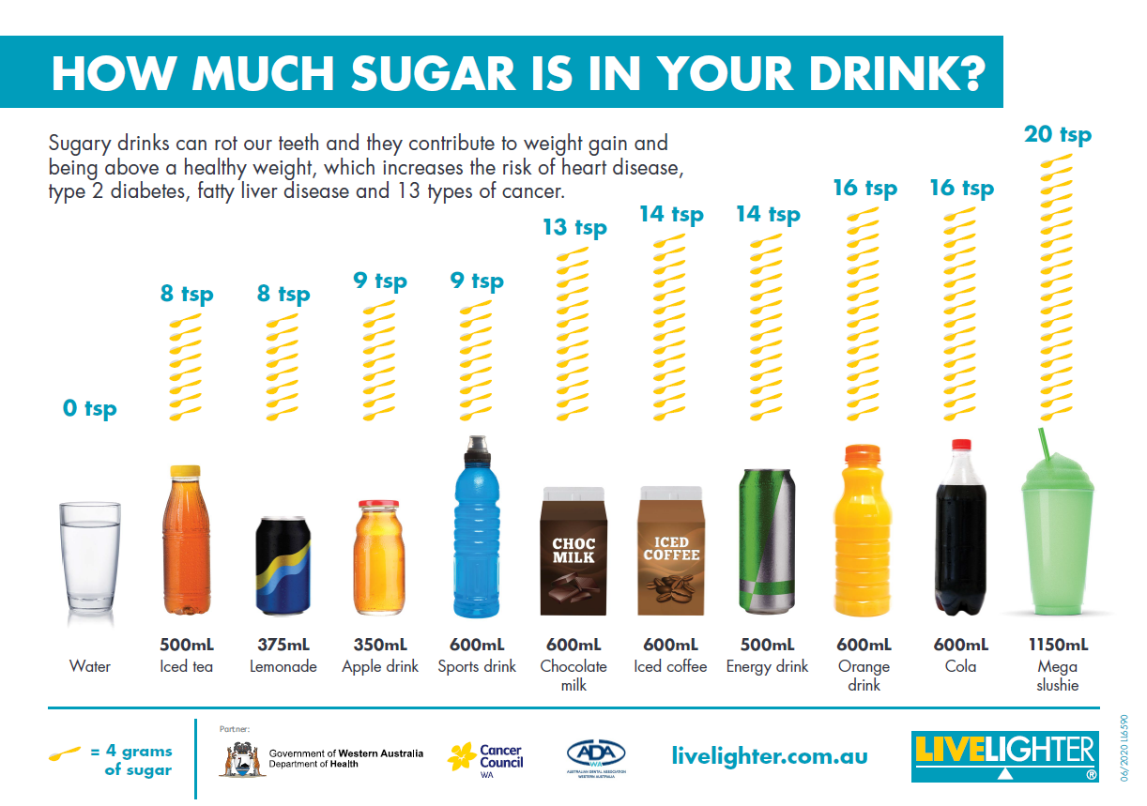

Properties: plain, alcoholic, carbonated

Instances: water, soft drinks, wine, coffee

Behaviours: satisfy thirsty, feel refreshed, wash food down

1. **Cooking Oil**



Properties: boiling point, smoking point, density, type

Instances: olive oil, palm oil, sunflower oil, peanut oil, coconut oil

Behaviours: dressing, roosting, frying, baking